LMS Online Quiz –

Create Calculated Type Questions

(Embed Random Variables)

- Open the question bank and navigate to the sub-category where you want to create the question.

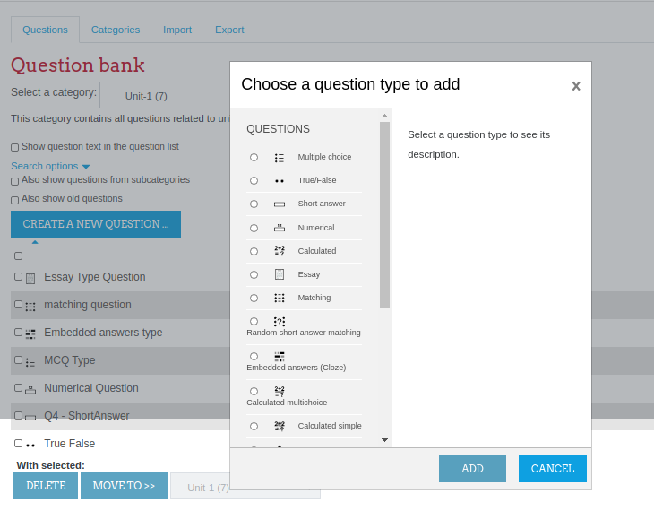

- Write name of the question (This name will not display to the students).
- Add question text. The variable for which you want to randomize its value for all students, should be written in curly brackets i.e. {Vs} in the question text.
- An image can be directly pasted in the editor.

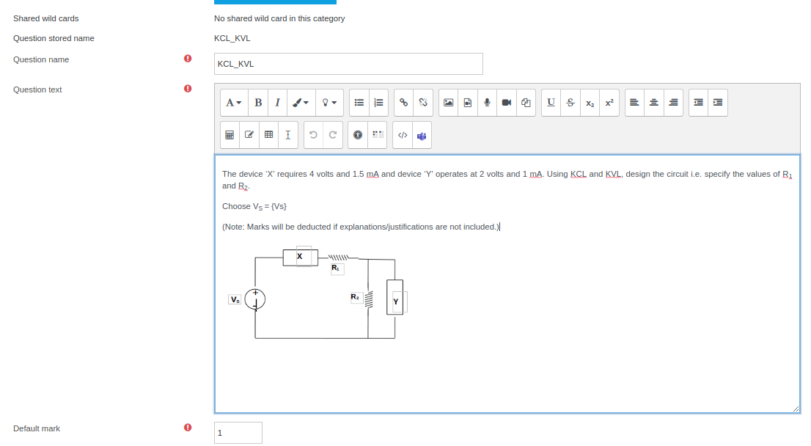
- Add the correct answer formula by using the variable and select “Grade” to 100%.
- Absolute or relative tolerance can be provided (if necessary).

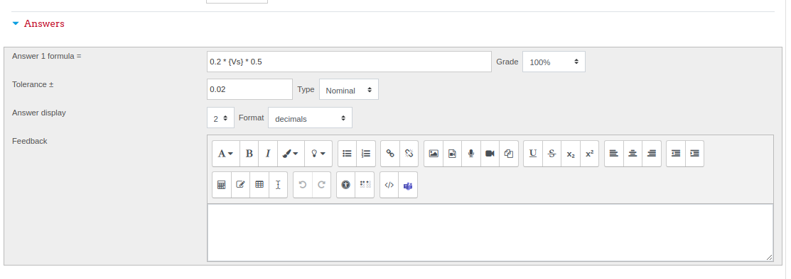

7. Click on “Save changes” button.

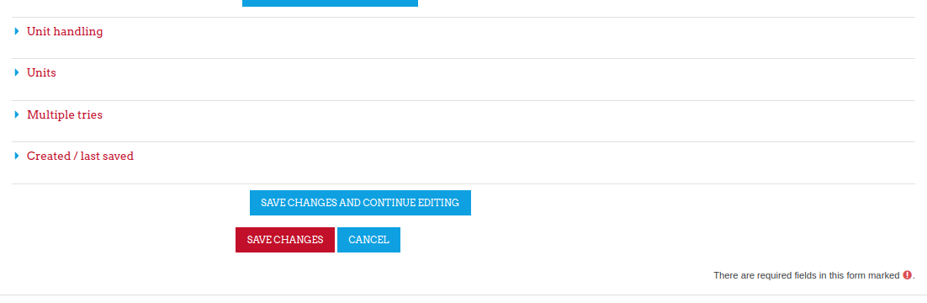
- Upon saving the changes, system will ask you to define the variable you have added into the question and its answer. (Variables are termed as “Wild Card” in LMS). If you do not want to share this variable among different qustions of your quiz, keep the default option selected i.e. Will use the same existing private dataset as before” and Do not synchronise. Click on “Next page”.

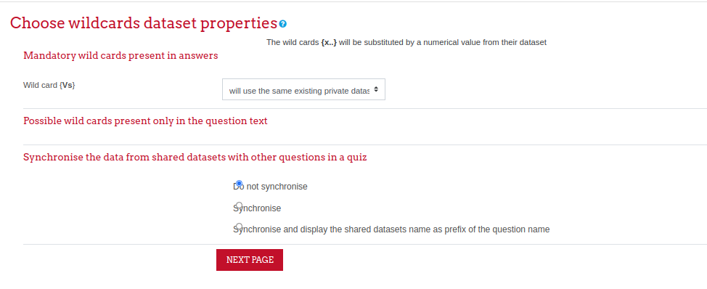

- Choose the range of variable by setting the minimum and maximum values. Adding decimal places will result in generation of more randomized set of variable values. Choose a distribution method for variable values.

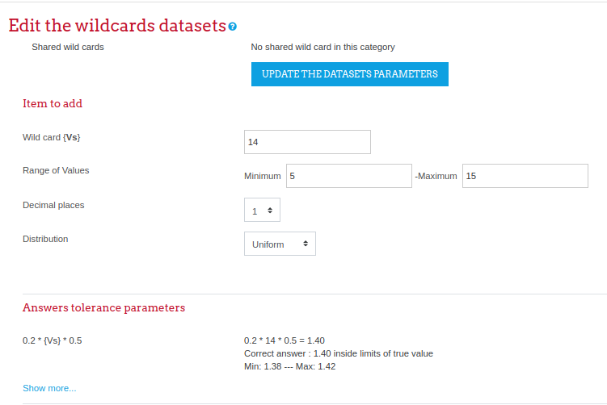

- Select the number of random sets you want to add for the variable(s) and click on “ADD” button. e.g. choosing 20 will generate 20 sets of this variable which will be distributed among the stduents during quiz.
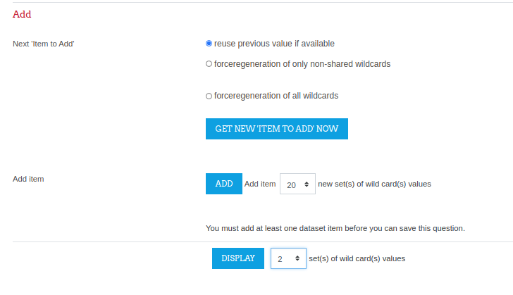

- You can choose any number to display the generated set of questions.
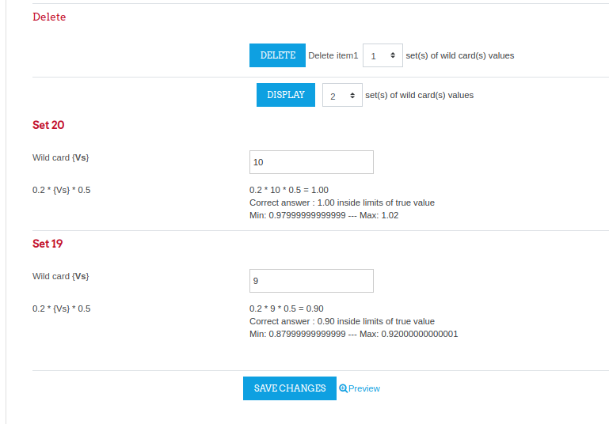

- Verify the answers from the displayed sets of questions and save the changes.
- Question is added into selected category of your question bank. Using preview icon (magnifying glass icon) you can preview how question will appear to the students.
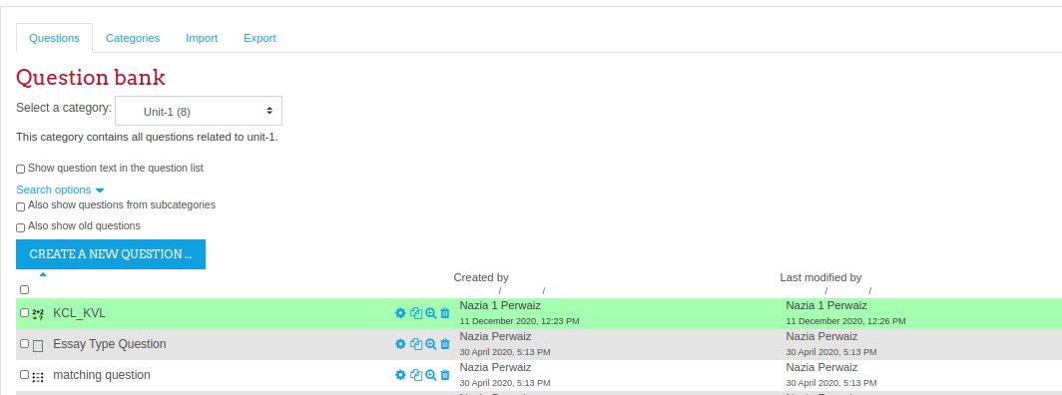
- Variable value is selected from the range you have defined while creating the question.

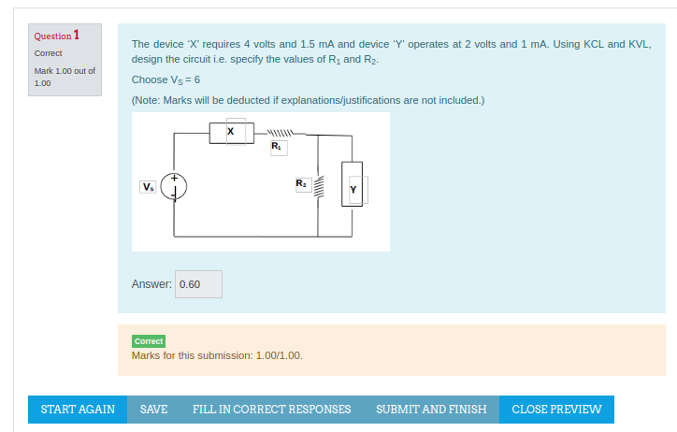

- Another preview of the same question will fetch a different value of the variable Vs.





